DESIGN (EXAMPLE)
PHOTO / CAD / SKETCH / DRAWING

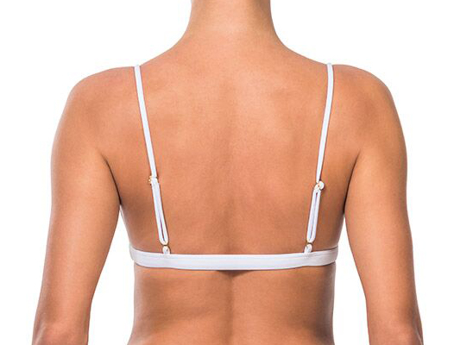
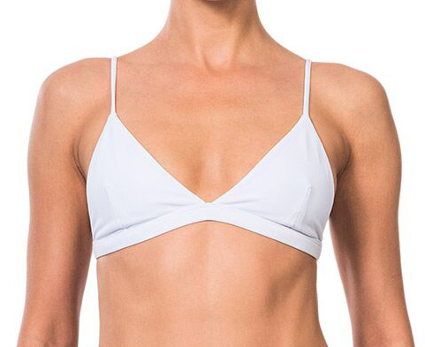

COMMENTS:

Fill in as many details as possible for your design. Refer to real sample where possible.
MEASUREMENTS (EXAMPLE)
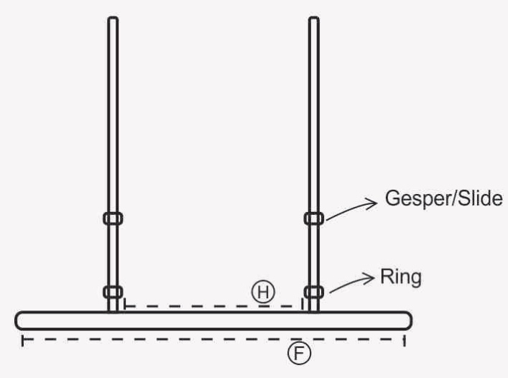
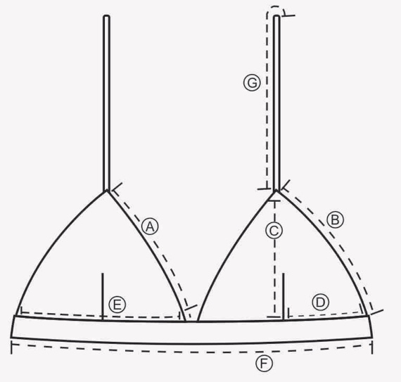

POINT OF MEASURE | NO. | MEASURE_(CM+/-0,5)
NECK UP | A | 16
SIDE CUP | B | 15.5
CUP HEIGHT | C | 16
POSITION DART | D | 9
CUP WIDTH | E | 17
UNDERBUST WIDTH | F | 32
STRAP LENGTH | G | 40
POSITION BACK STRAP | H | 14

GRADING PATTERN (EXAMPLE)

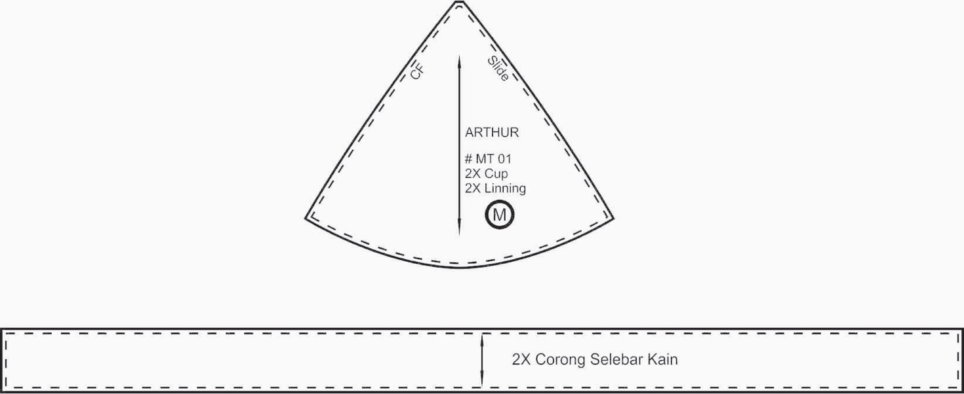

NO. | POINT OF MEASURE | SIZES
 |  | XXS | XS | S | M | L | XL
A | NECK UP
B | SIDE CUP
C | CUP HEIGHT
D | POSITION DART
E | CUP WIDTH
F | UNDERBUST WIDTH
G | STRAP LENGTH
H | POSITION BACK STRAP
I
J
K
L
M
N
O

ACCESSORIES (EXAMPLE)
HARDWARE APPROVED AND DETAILS (SIZE and LOCATION)
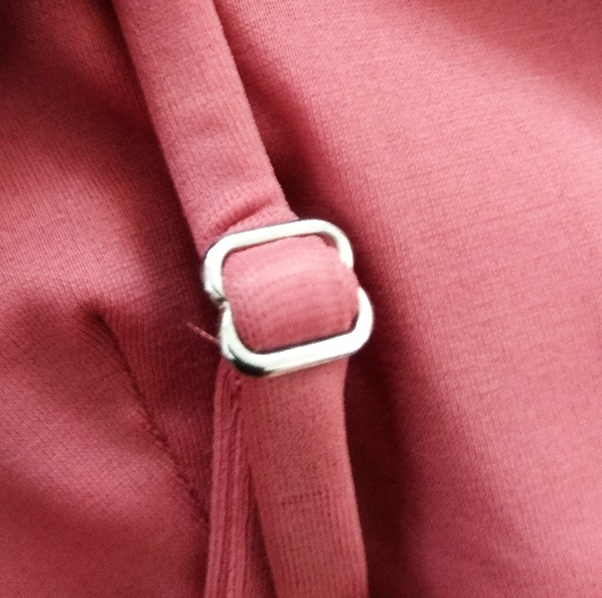
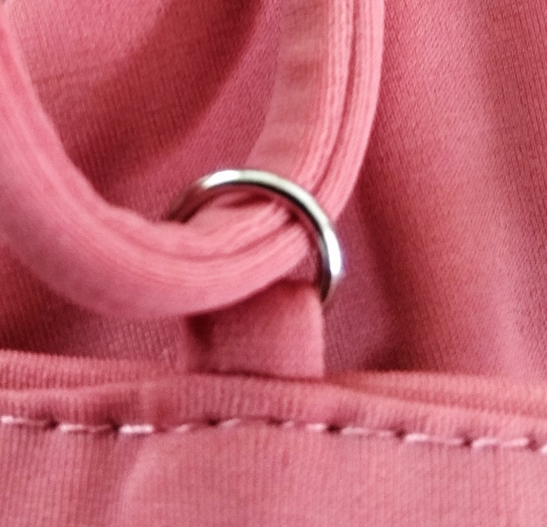

LABEL & CARE LABEL (EXAMPLE)

- LOGO APPROVED WITH SIZE AND LOCATION DETAILS (MEASUREMENT IN CM ALSO FOR DISTANCE)

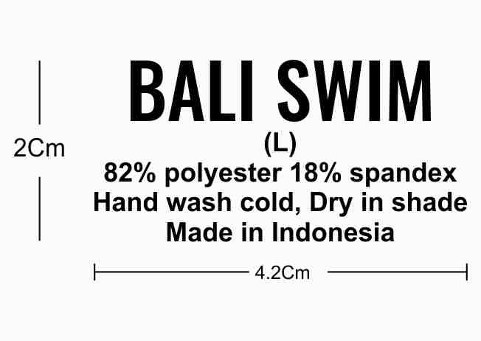

- CARE LABEL APPROVED AND IN LOCATION DETAILS:

PACKING ACCESSORIES (EXXAMPLE)
- COTTON BAG / PLASTIC BAG APPROVED AND DETAILS

- SANITARY STICKER
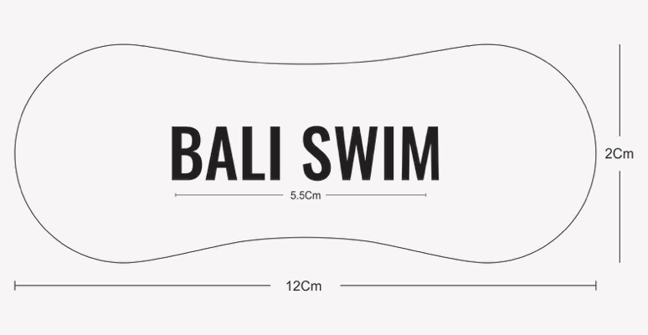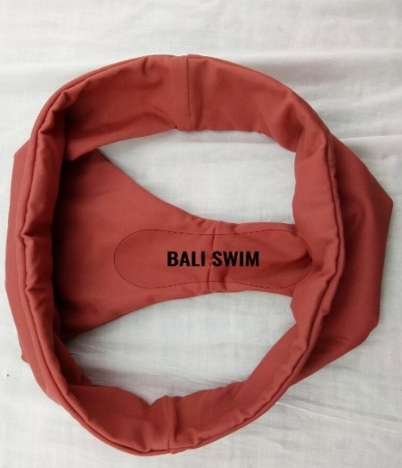

- HANG TAG
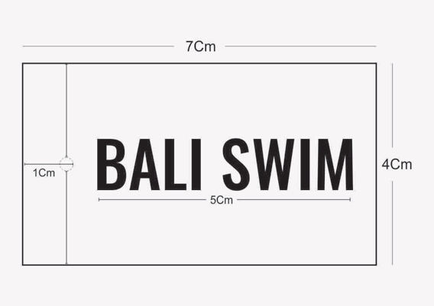

PRINT ARTWORK DETAILS (EXAMPLE)

