DESIGN (EXAMPLE)
PHOTO / CAD / SKETCH / DRAWING

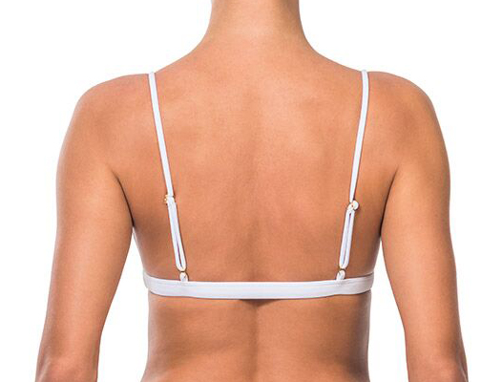
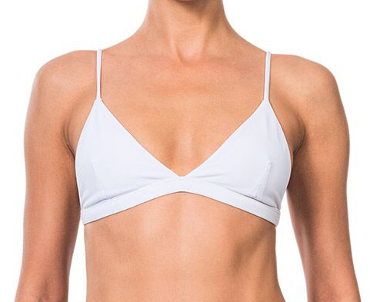

COMMENTS:

Fill in as many details as possible for your design. Refer to real sample where possible.
MEASUREMENTS (EXAMPLE)
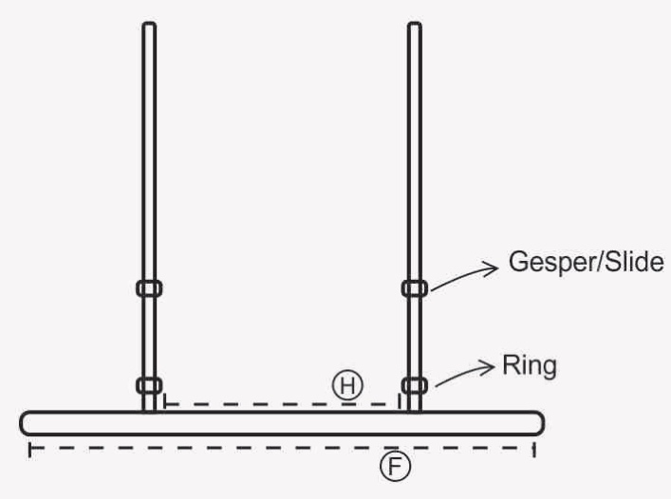
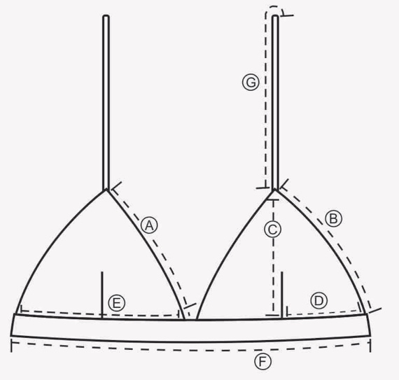

POINT OF MEASURE | NO. | MEASURE_(CM+/-0,5)
NECK UP | A | 16
SIDE CUP | B | 15.5
CUP HEIGHT | C | 16
POSITION DART | D | 9
CUP WIDTH | E | 17
UNDERBUST WIDTH | F | 32
STRAP LENGTH | G | 40
POSITION BACK STRAP | H | 14

ACCESSORIES (EXAMPLE)
HARDWARE APPROVED WITH DETAILS (SIZE & LOCATION)
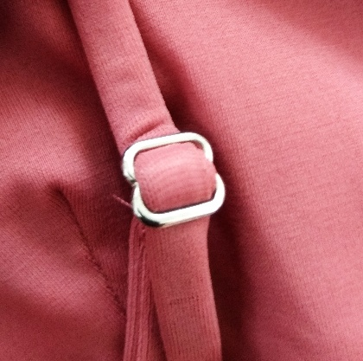
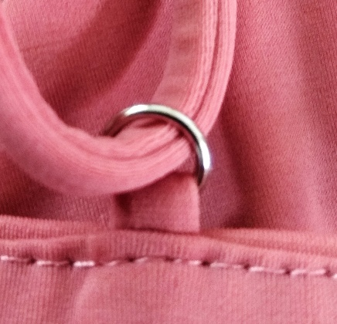

PRINT ARTWORK DETAILS (EXAMPLE)

